✦ · ✧ · ✦ · ✧ · ✦
Types of Prompts
A spellbook of prompting techniques, with examples, screenshots and flow diagrams
Every prompt is a spell: the way you word it changes the magic you get back. Here are nine ways to cast it.

01 Zero-shot prompting
No example is given. The model relies only on what it already knows.
Example “Translate this sentence into Hindi”

02 One-shot prompting
One example is given, so the model can copy the pattern.
Example “Cat → बिल्ली. Dog → ?”
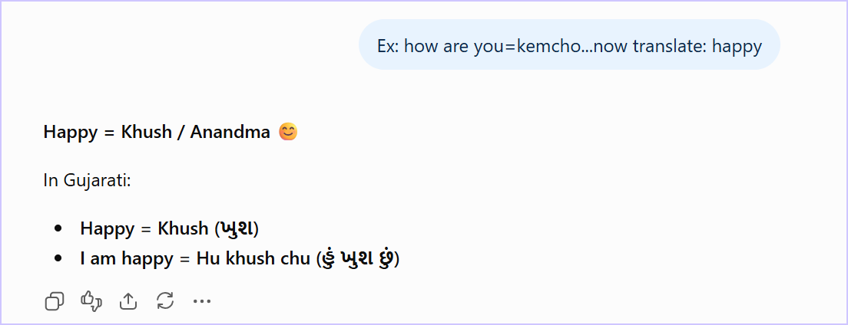
✦ Screenshot 1 · One example (how are you = kemcho), then “translate: happy”.
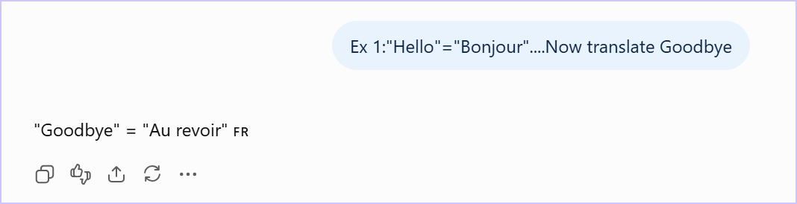
✦ Screenshot 2 · One example (Hello = Bonjour), then “translate Goodbye”.

03 Few-shot prompting
Two or more examples are given, which makes the pattern even clearer.
Example “Cat → बिल्ली, Dog → कुत्ता, Cow → ?”

04 Chain-of-thought (CoT)
Ask the model to reason step by step before answering.
Example “Solve this problem step by step.”

05 Role prompting
Give the AI a role to play.
Example “You are a Python teacher. Explain loops.”

06 Instruction prompting
Gives a clear, direct instruction.
Example “Summarize this paragraph in 3 points.”
The two screenshots below are instruction prompts too: a plain-English description of a function, followed by a clear instruction to write its JSON schema.
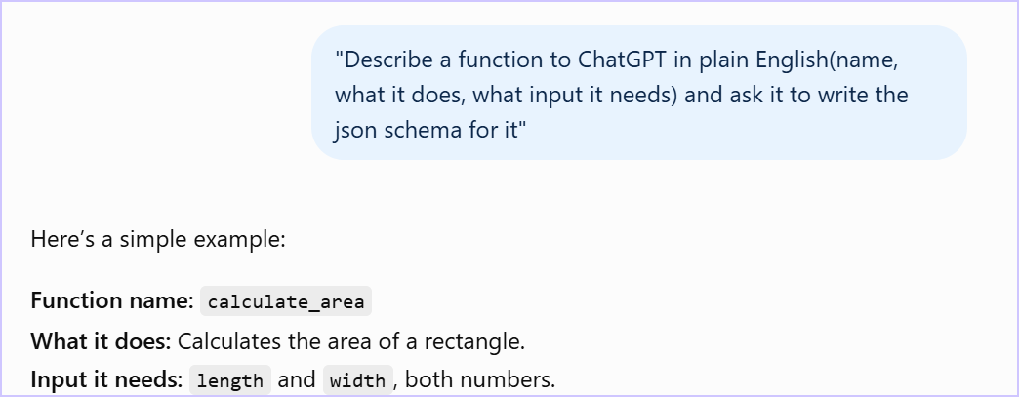
✦ Screenshot 1 · The prompt: describe a function in plain English and ask for its JSON schema.
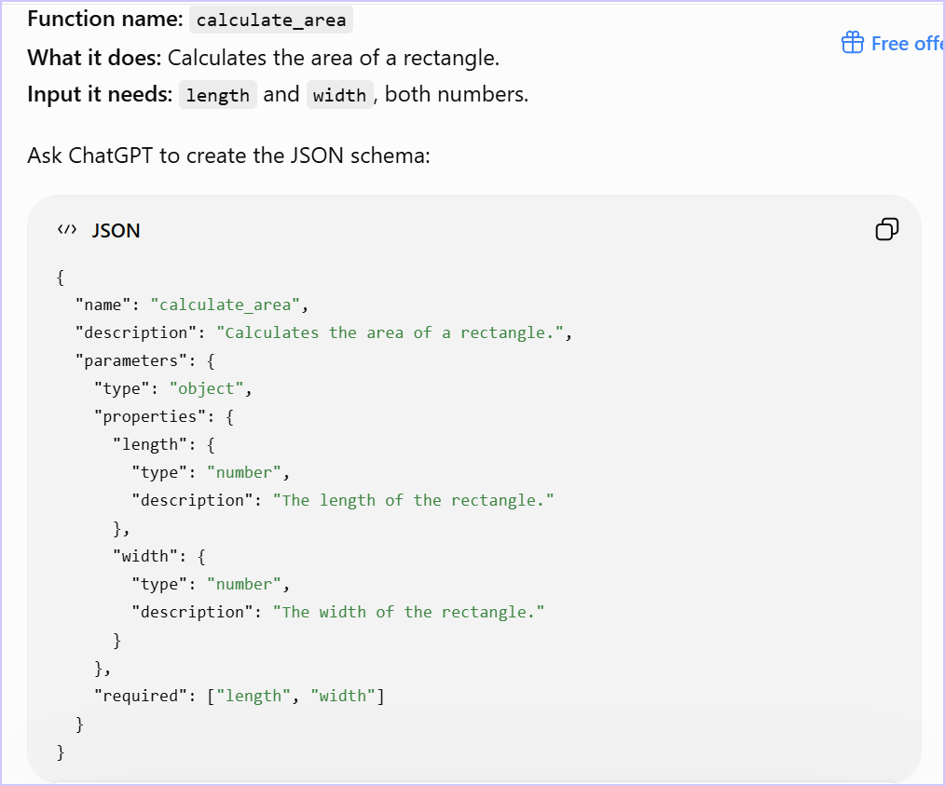
✦ Screenshot 2 · The result: ChatGPT returns the JSON schema for calculate_area.

07 Context prompting
Provides background or context first.
Example “You are helping a beginner who knows basic Python…”

08 Persona prompting
Sets a particular personality or style.
Example “Explain like a friendly teacher.”

09 Negative prompting
Says what not to do.
Example “Do not use technical words.”

✦ From prompt to action
How structured prompts become tool calls, and how the output gets checked

Diagram 1 End-to-end tool flow
The user asks a question, the model decides to call a tool, the backend runs it, and the model turns the result into a plain answer.
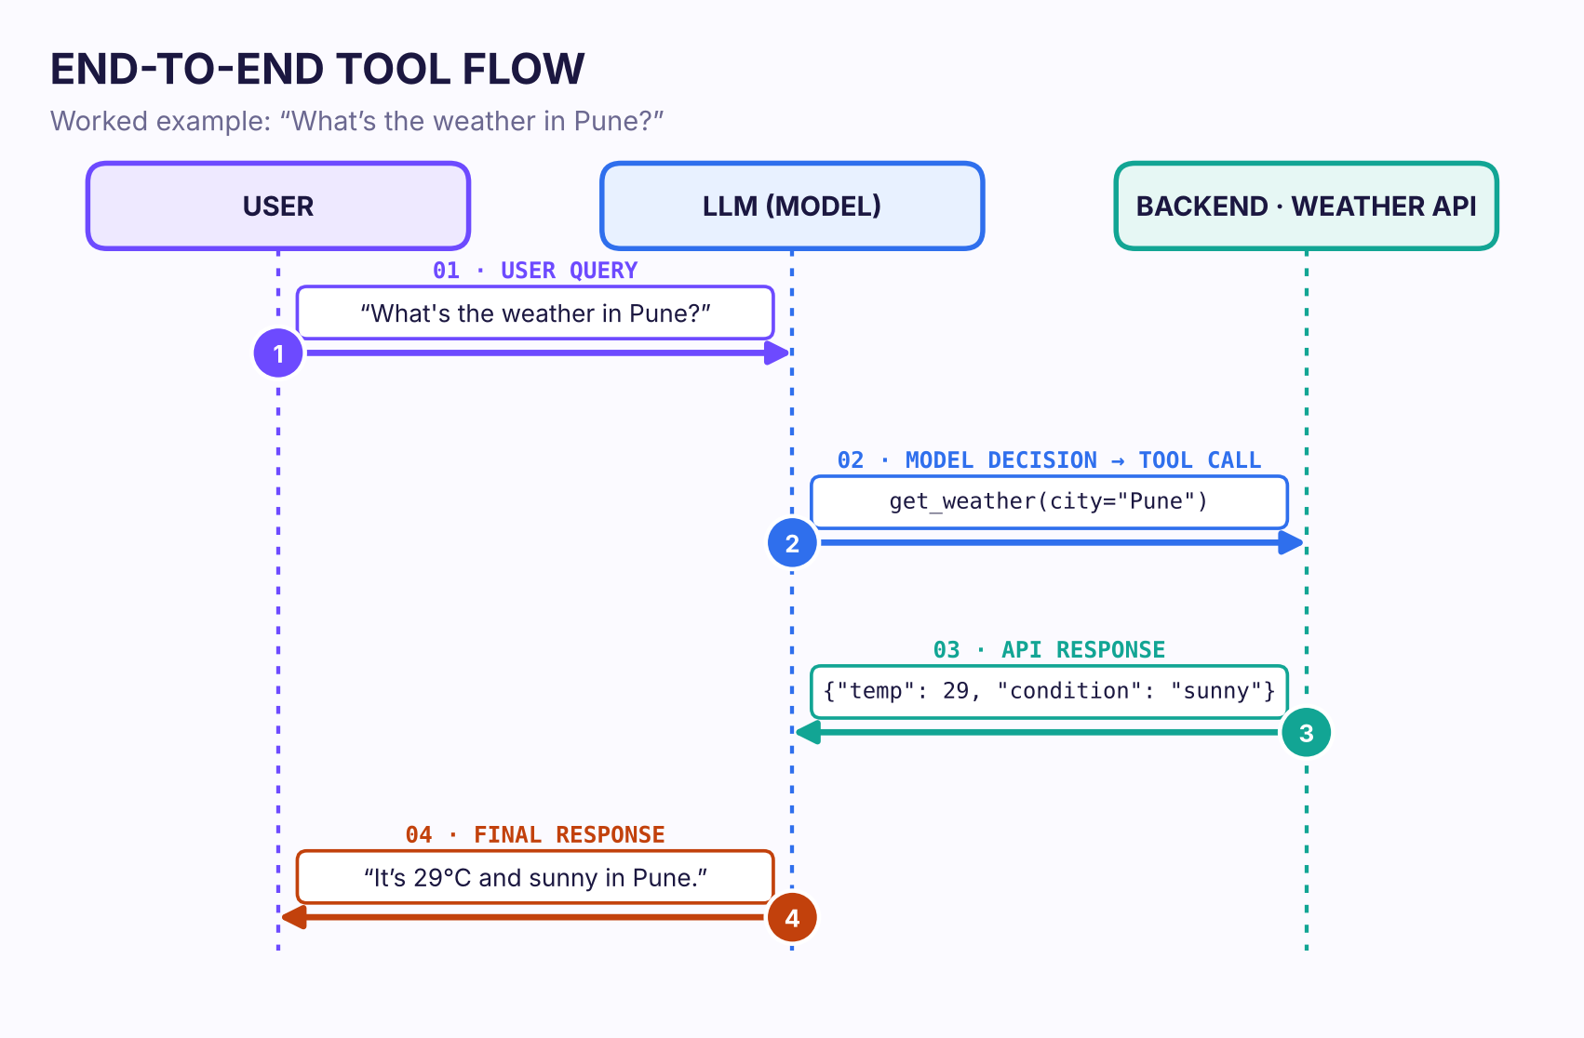
✦ Sequence of messages between the user, the model and the backend API.

Diagram 2 Output validation loop
The model’s raw output is checked against a schema. If it is valid it is returned; if not, the error is caught and a repair prompt sends it round again.
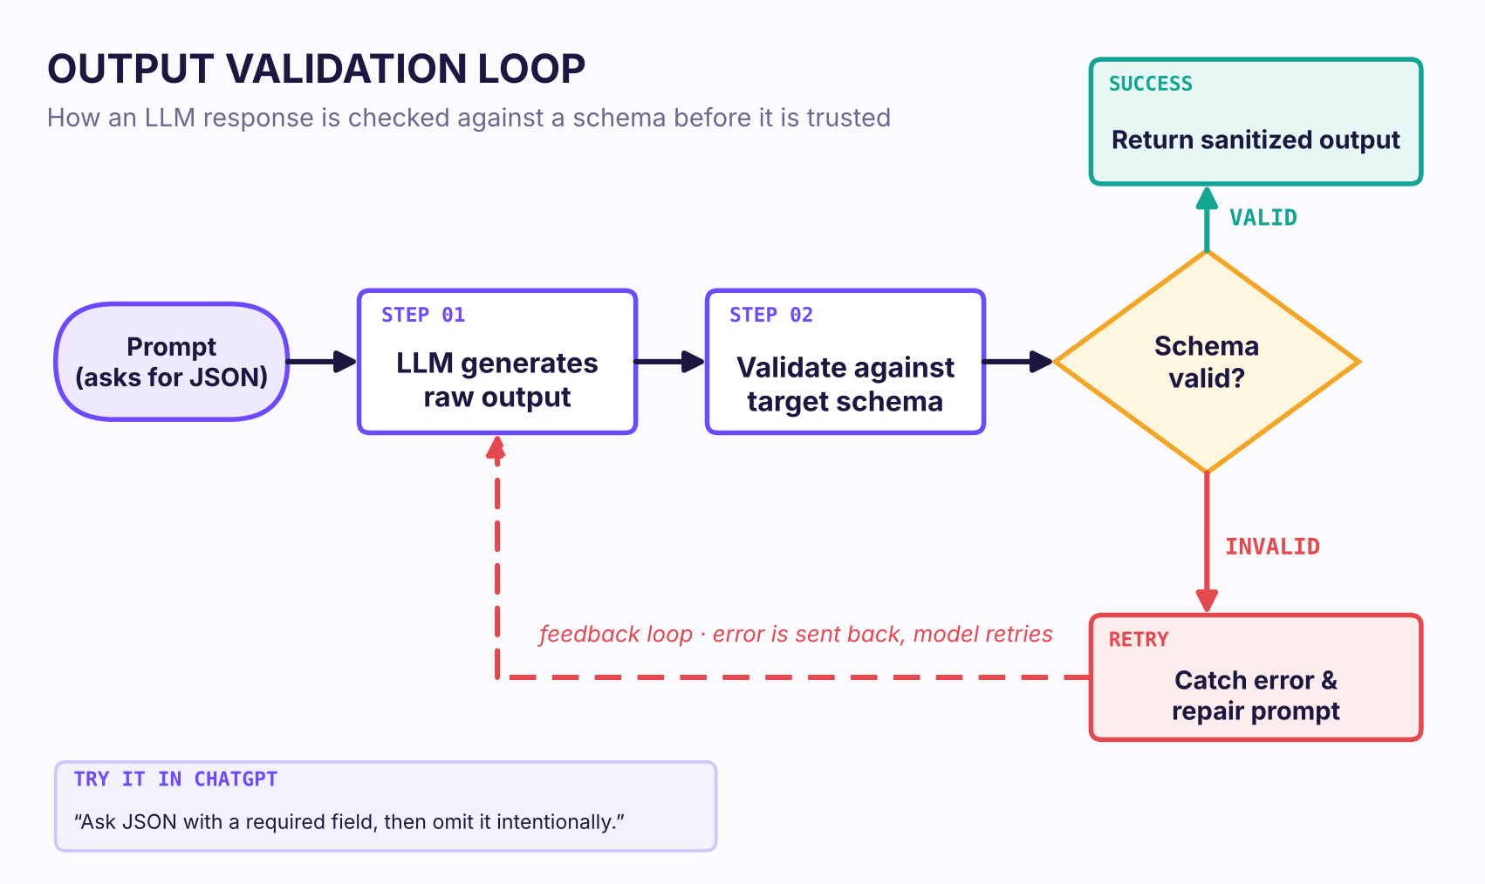
✦ Flowchart with the valid / invalid decision and the retry loop.

